**Lab 9: Lists**

**Question1:**

Write a program that reads some integers between 1 and 100 and counts the occurrences of each. Here is a sample run of the program:

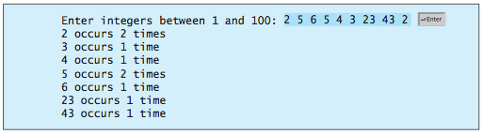

Note that if a number occurs more than one time, the plural word “times” is used in the output.

**Question 2:**

Write a program that reads an unspecified number of scores and determines how many scores are above or equal to the average and how many scores are below the average. Assume the input numbers are separated by one space in one line.

**Question 3:**

Write a program that reads in numbers separated by a space in one line and displays distinct numbers (i.e., if a number appears multiple times, it is displayed only once). (Hint: Read all the numbers and store them in **list1**. Create a new list **list2**. Add a number in **list1** to **list2**. If the number is already in the list, ignore it.) Here is the sample run of the program:



**Question 4:**

Write a function that returns the index of the smallest element in a list of integers. If the number of such elements is greater than 1, return the smallest index. Use the following header:

**def** indexOfSmallestElement(lst):

Write a test program that prompts the user to enter a list of numbers, invokes this function to return the index of the smallest element, and displays the index.